

Join PPS Title VI Indian Education for

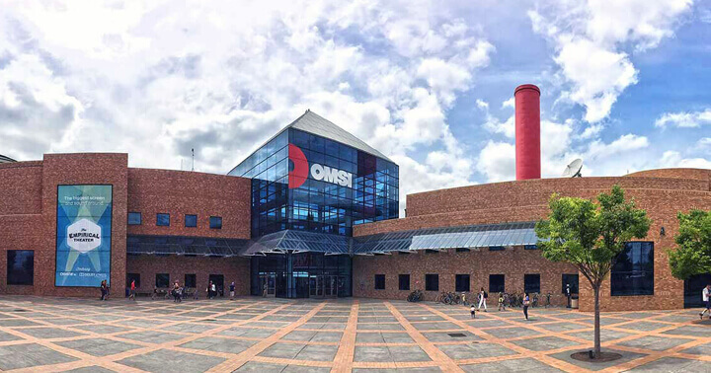OMSI FAMILY NIGHT

P

Monday, September 16 – 6:00 PM-8:00 PM

1945 SE Water Ave, Portland, OR 97214 / [indianeducation@pps.net](mailto:indianeducation@pps.net) / (503) 916-6499